Question 1:
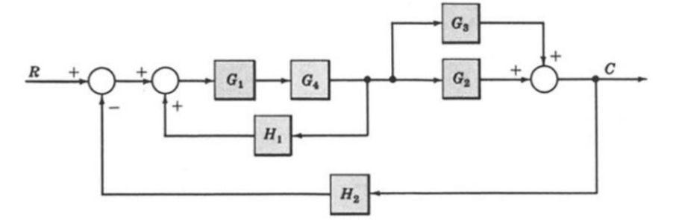

Question 2:
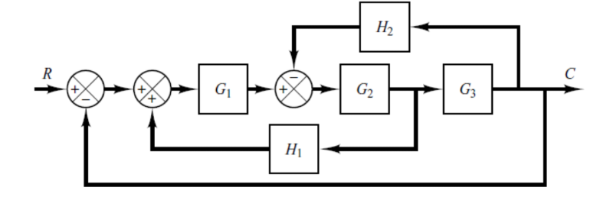

Question 3:
A smart oven uses a PID controller to maintain a constant temperature of 200°C for baking. Due to heat loss when the oven door is opened and fluctuations in ambient conditions, the temperature keeps changing. The oven has been preheated at 150°C for better baking experience.
The PID controller parameters are: Kp​=0.6, Ki​=0.2, Kd​=0.1
- Simulate 5 time steps of the oven’s temperature control system. For each step, calculate:
- Error
- Proportional, Integral, and Derivative terms
- Controller Output
- New Temperature
- Draw the graph showing how the oven reaches its goal over time.

